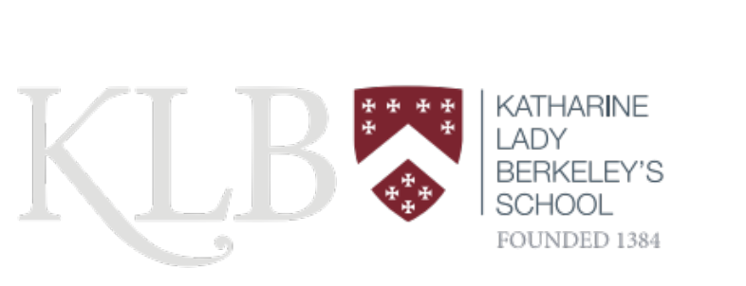

Newsletter

May 2026

May has been one of those months during which so much activity has taken place that the newsletter almost writes itself. Alongside lessons and formal examinations, students have taken part in exchanges, expeditions, visits, work experience placements, performances, competitions and celebrations. As always, the enthusiasm with which they have embraced these opportunities is impressive.

A particular highlight was welcoming our French exchange partners from Bois-le-Roi. Now in its 37th year, the exchange remains a valued part of school life. It was wonderful to see friendships develop so quickly and to hear such positive feedback from our visitors about both the programme and the hospitality shown by students and families. During their visit, students enjoyed everything from art and Japanese lessons at KLB to trips to Stratford, Big Pit and Bath, while host families ensured that our visitors experienced the very best of the local area.
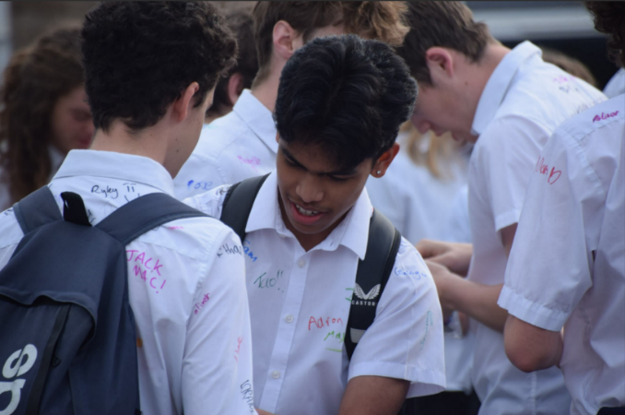

This month also marks important milestones for two year groups. We said goodbye to our Year 13 students as they completed their final week in school before examinations, and Year 11 enjoyed their Celebration Day. Both occasions were full of laughter and reflection, providing an opportunity to celebrate all that the students have contributed during their time at KLB and to wish them every success for the weeks ahead.
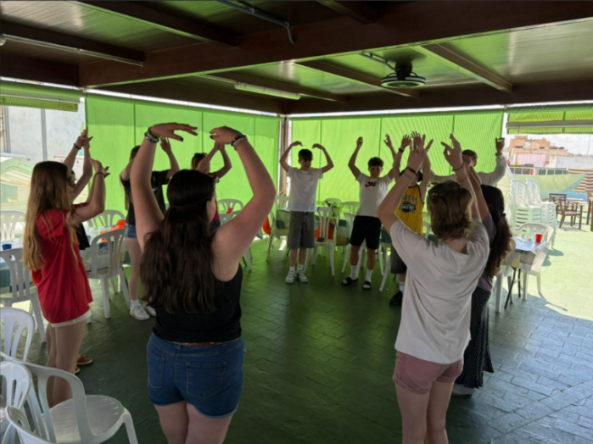
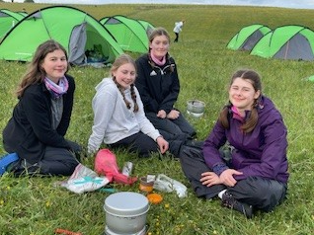
Elsewhere, students travelled to Spain to immerse themselves in the language and culture, through Spanish lessons, flamenco dancing, paella making or simply putting their language skills to the test in cafés, restaurants and markets. Our Duke of Edinburgh participants completed practice expeditions across Dartmoor, the Wye and the Quantocks, while Year 12 students spent Activities Week pursuing an impressive range of opportunities, from work experience and university preparation to first aid training, volunteering and Gold DofE.

As always, this newsletter offers a window into life at KLB. I hope you enjoy reading about the many experiences and achievements of KLB students.

Hannah Khan, Headteacher

Goodbye Year 13!

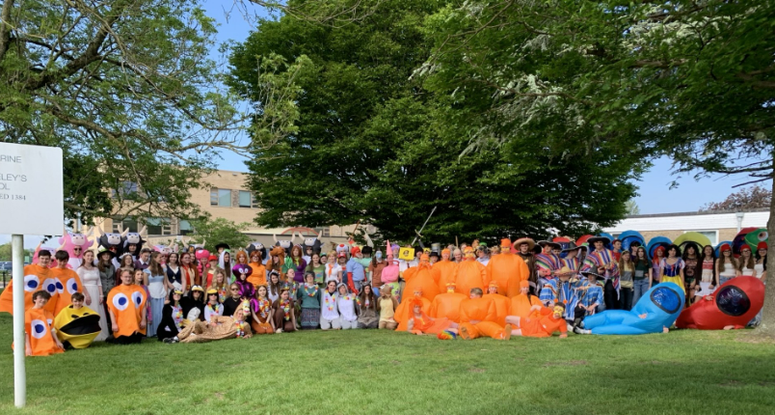
The sun shone on our departing year 13s during their final week celebrations marking this important milestone. The long-established tradition of kicking the week off by squeezing into old school uniform caused more than one teacher to do a double take. It was great to see a considerable variety of uniforms that is testament to the number of students we welcomed into the sixth form from other schools. Hawaiian shirts brought colour and fun to the penultimate day as we enjoyed BBQ, ice-creams and rounders for the afternoon.

Characterised by their inclusiveness, warm-heartedness, and demonstrating considerable resilience amidst all the changes of the last few years, this cohort have also proved to be endlessly enthusiastic – whether through sporting activities, drama and music, volunteering, supporting departments and the wider community or through social events – so it is no surprise that their final dress-up day brought so much joy to the whole school. Period 1 and 2 lessons played host to Scooby-Doo, Among Us, a Mariachi Band, the farmer with his pigs and cows, fairy tale favourites, Madagascar, Pacman, Super Mario, SpongeBob, Medieval Knights, Where’s Wally and the Loraxes who spread delight and just a little mayhem wherever they went.

Of course, they have also worked extremely hard, and it was not really a surprise to see so many of them revising in the study library the following day. We wish them every success in their summer exams and beyond.

Jane Campion, Head of Sixth Form

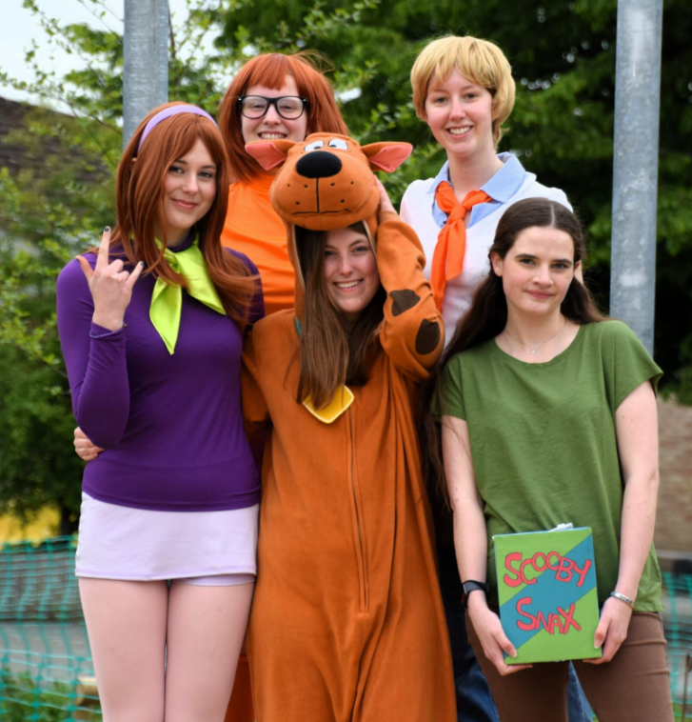

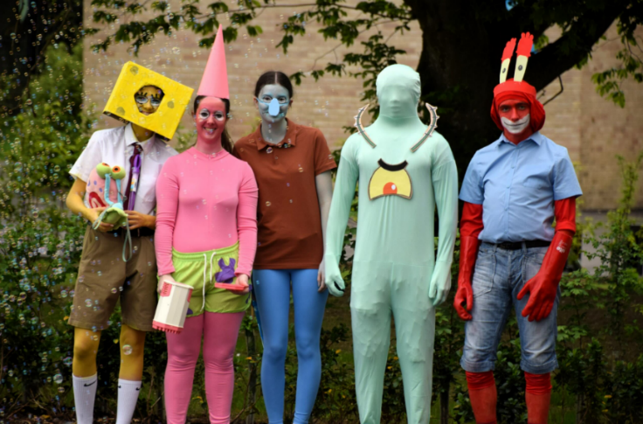

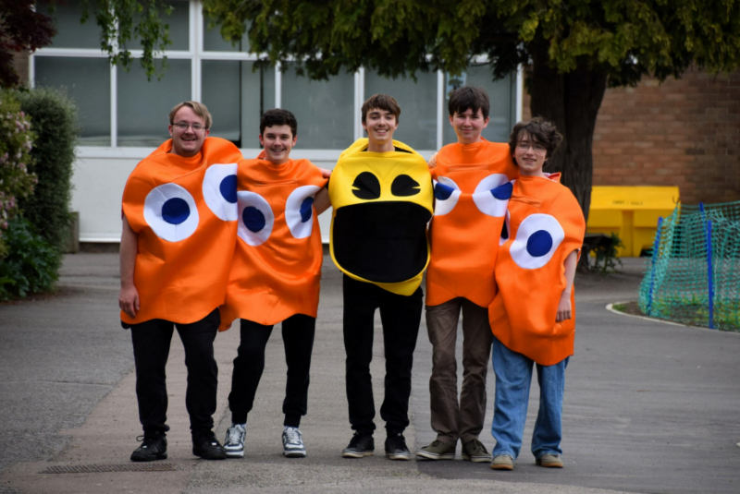
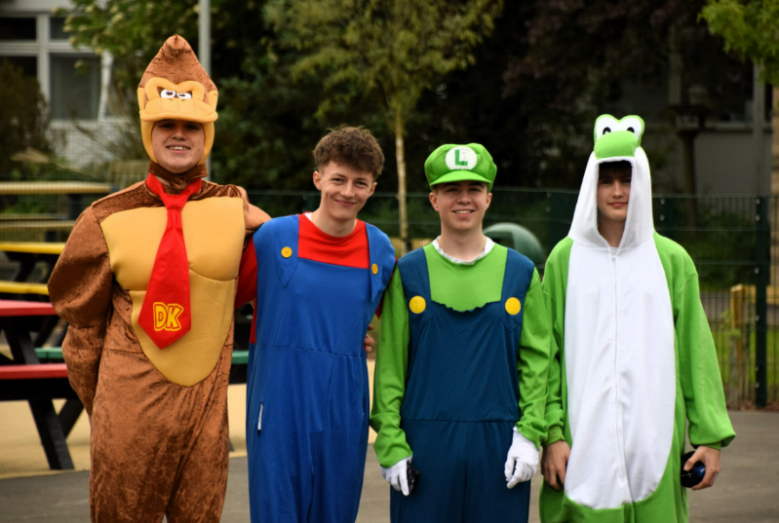
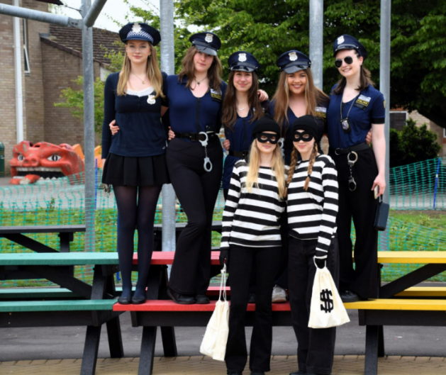
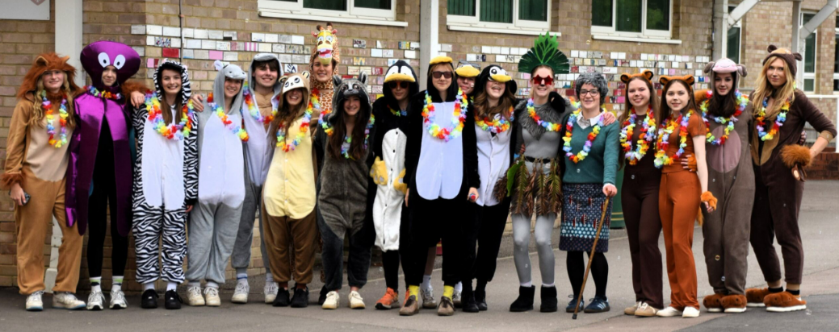
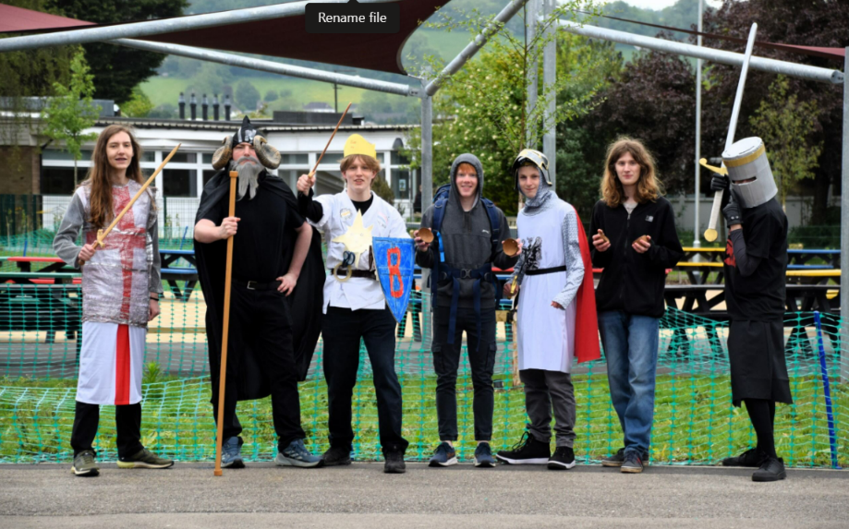
French Exchange: 1989–2026

In May, we were thrilled to welcome 24 students and three teachers from our partner school, Collège Denecourt in Bois-le-Roi, as we proudly celebrate 37 years of the French exchange.
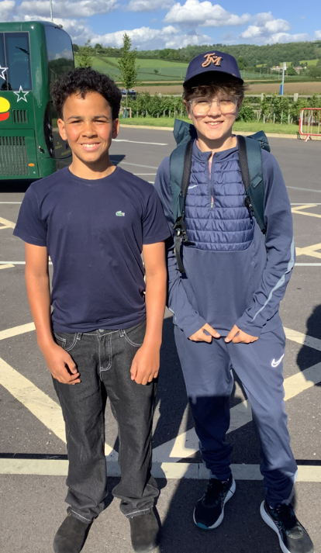
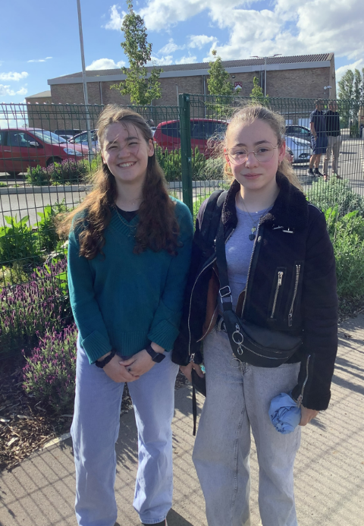
After their long journey, our French visitors received a warm and enthusiastic welcome from their host families, who filled the week with fun, memorable activities. The programme got off to a great start with a welcome from Miss Khan, followed by a bilingual meet-and-greet that quickly broke the ice. Students also enjoyed lessons in art and Japanese – many thanks to Mr Chilman and Mr Bufton for sessions that proved to be real highlights of the week.

The excitement continued with trips beyond Wotton, including a behind-the-scenes theatre tour and workshop in Stratford, an unforgettable visit to Big Pit in Wales and a journey through history at the Roman Baths and Bath Abbey.
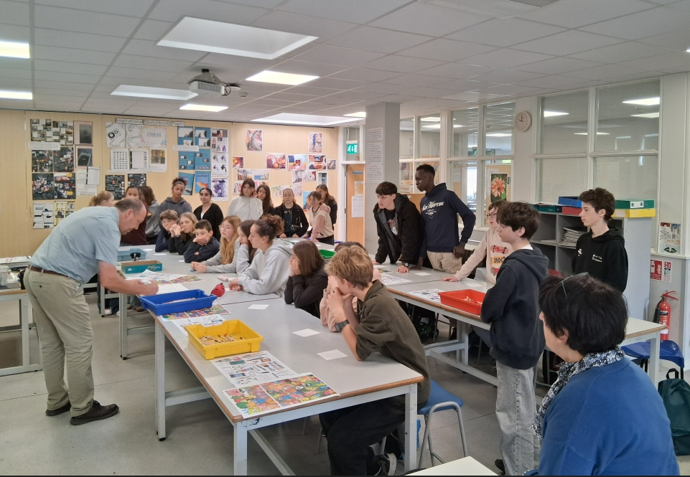
With glorious sunshine throughout, our visitors saw Wotton and the surrounding area at their very best. Host families organised a wide range of activities - from exploring Bristol and the SS Great Britain to countryside walks and enjoying classic fish and chips.

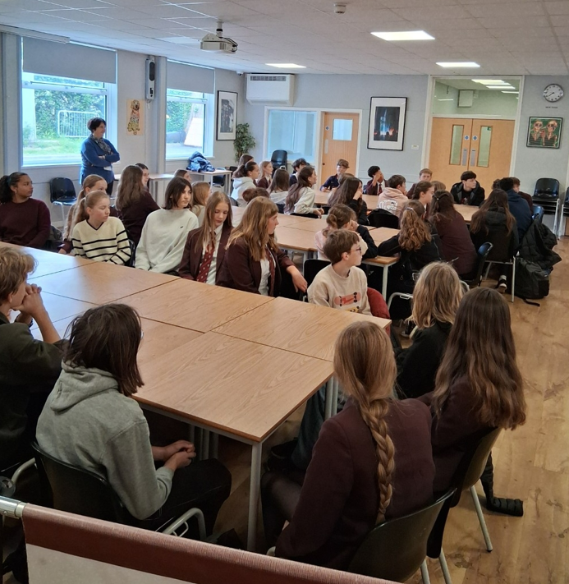
A huge thank you to everyone involved in making the exchange such a resounding success. Our French partners had an incredible time and are already eagerly preparing to welcome KLB students after half term - we can’t wait!

S Jones, Head of Languages

Year 11 Celebration Day

This year’s Year 11 Celebration Day provided a fitting send off for a fantastic group of students. It has been a privilege to be their Head of Year, and the atmosphere across the day was truly special — a genuine sense of community, pride, and celebration that is hard to put into words.

Students embraced the tradition of signing each other’s shirts and books, sharing messages and memories that will serve as lasting reminders of their time together. These small moments reflected the strong relationships and sense of belonging that have defined this year group.

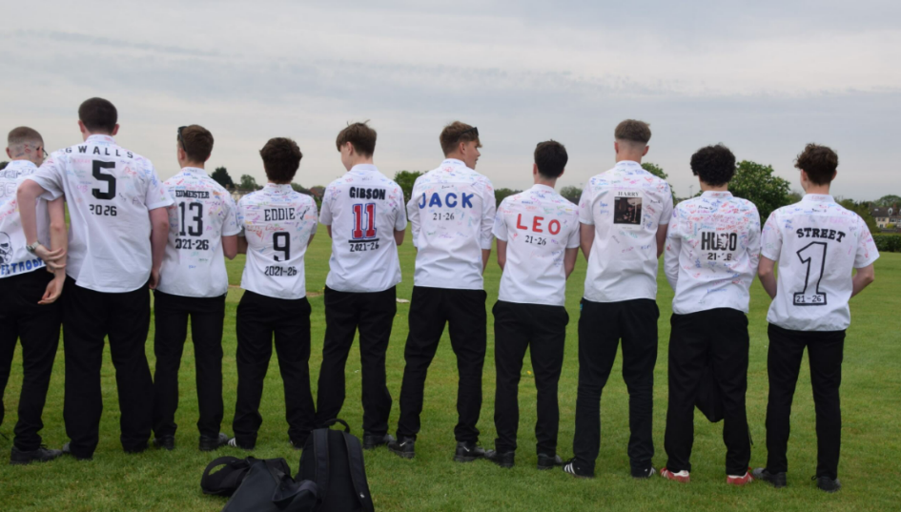
The day ended with a celebration assembly, where we recognised achievements through year group awards and enjoyed an outstanding musical performance. It was a moment that balanced celebration with reflection as students marked the end of this chapter.

As they now move into the exam season, we wish all Year 11 students every success. Their commitment and hard work have been clear throughout the year, and we are confident they will rise to the challenge ahead. We look forward to seeing all they go on to achieve.

R Dolan, Head of Year 11
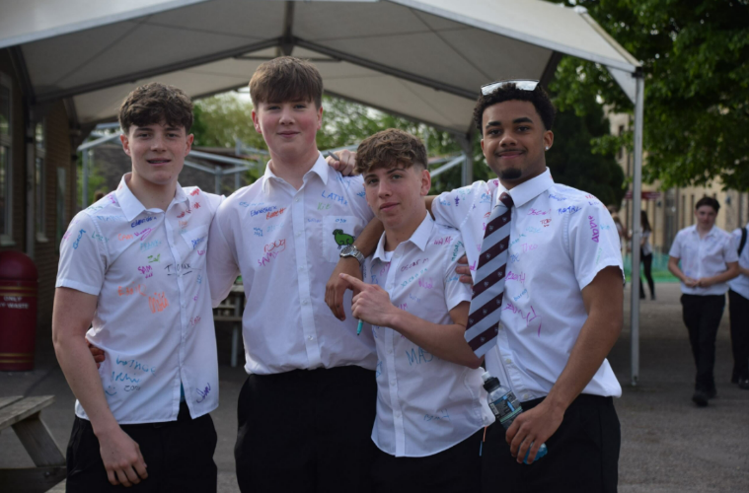
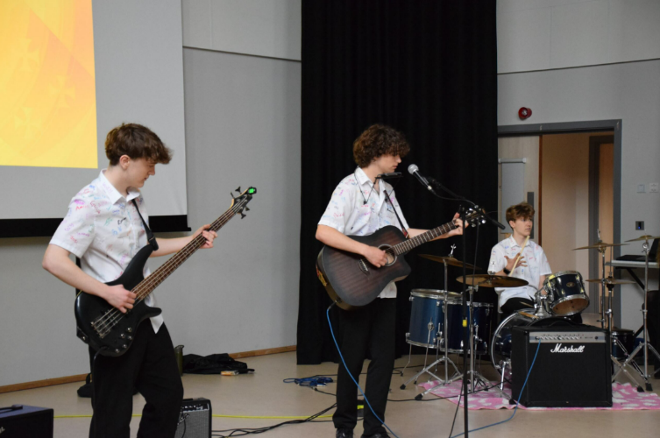

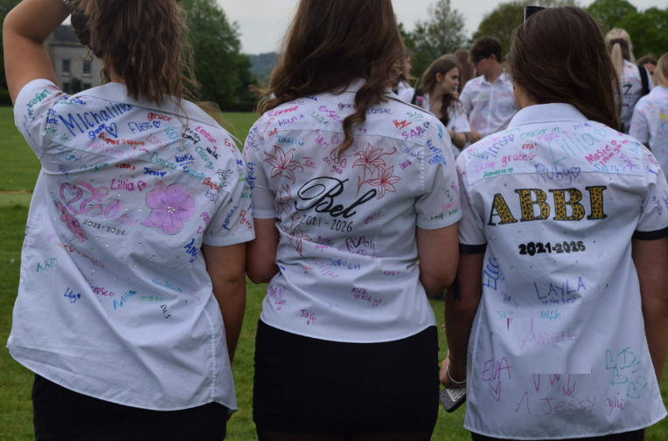
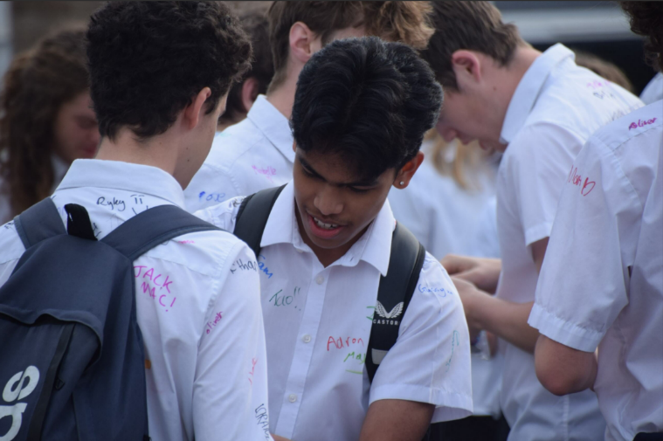

Year 10 Trip to El Puerto De Santa María, Cádiz, Spain

What a whirlwind of culture, conversation and culinary delights we experienced in the town of El Puerto de Santa María with year 10 students! Arriving in Gibraltar, passing through UK and Spanish borders, giving a wave to Morocco seen in the distance, set the tone for what would be three days of new sights, sounds and Spanish encounters.
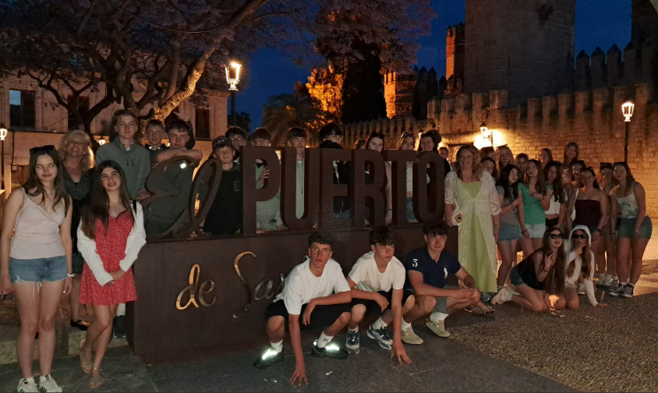
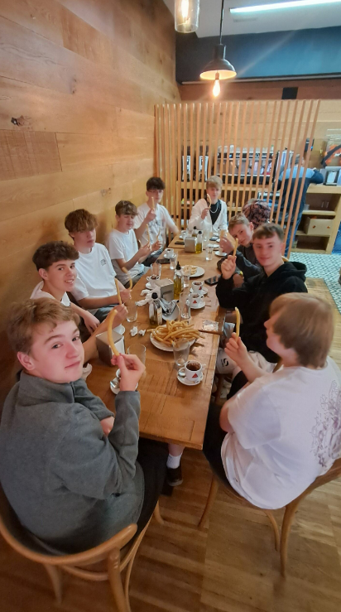
On arriving at Sparks hostel, we went straight up to the azotea (rooftop) for our first meal together. Staff were impressed with the cries of ‘delicioso’ and ‘muy rico’ coming from los estudiantes. Indeed, right from the first moment the effort our year 10 students made to listen to, speak and understand el español was impresionante. A wander at dusk around the beautiful pueblo ended our day and images of the plaza de toros, la heladaría and storks atop the iglesia filled our heads as we went to la cama.

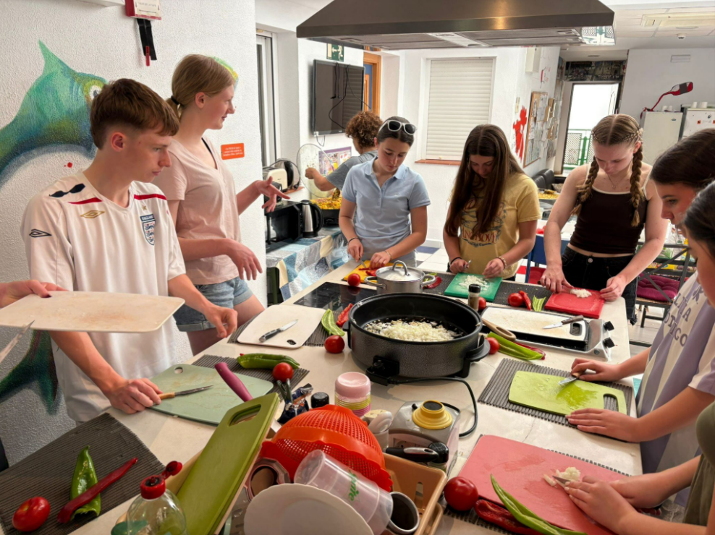
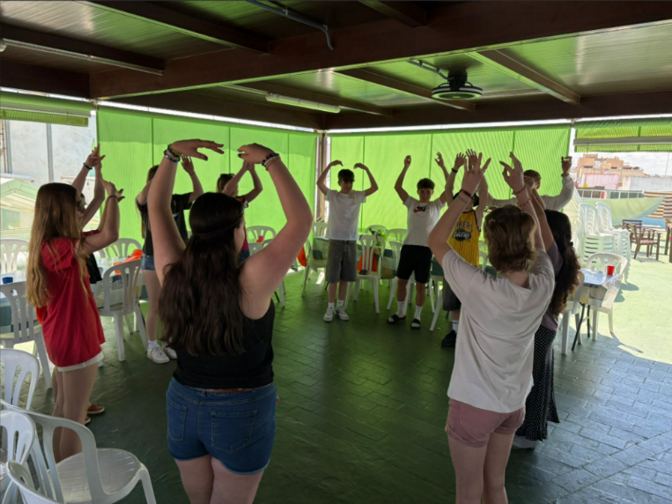
The second day kicked off with a bang with chocolate y churros in a local cafetería. The plates of churros kept coming and were a desayuno perfecto before heading into our carousel of actividades: Spanish lessons; flamenco dancing; paella making. All these were delivered in Spanish and the students seemed keen to cook paella once back en casa. They can confidently say the difference between ajo, ojo, hoja now too! We ate their paella for lunch which filled us up nicely before hitting la playa. To end the day, we had tapas in a local restaurant. The popular choices were salmorejo, patatas bravas y carne con tomate: ¡todos muy típicos! The chicos threw themselves into this very real experience; ordering in Spanish, trying platos nuevos and communicating with the camarero in Spanish.

Following a rooftop breakfast on the third day and an hour’s Spanish lesson, we caught the ferry across to Cádiz. The estudiantes made the most of their tiempo libre: lunch in the food market, asking for items in las tiendas in Spanish. Los profesores were amused by how much the vocabulary for ice cream flavours had improved!

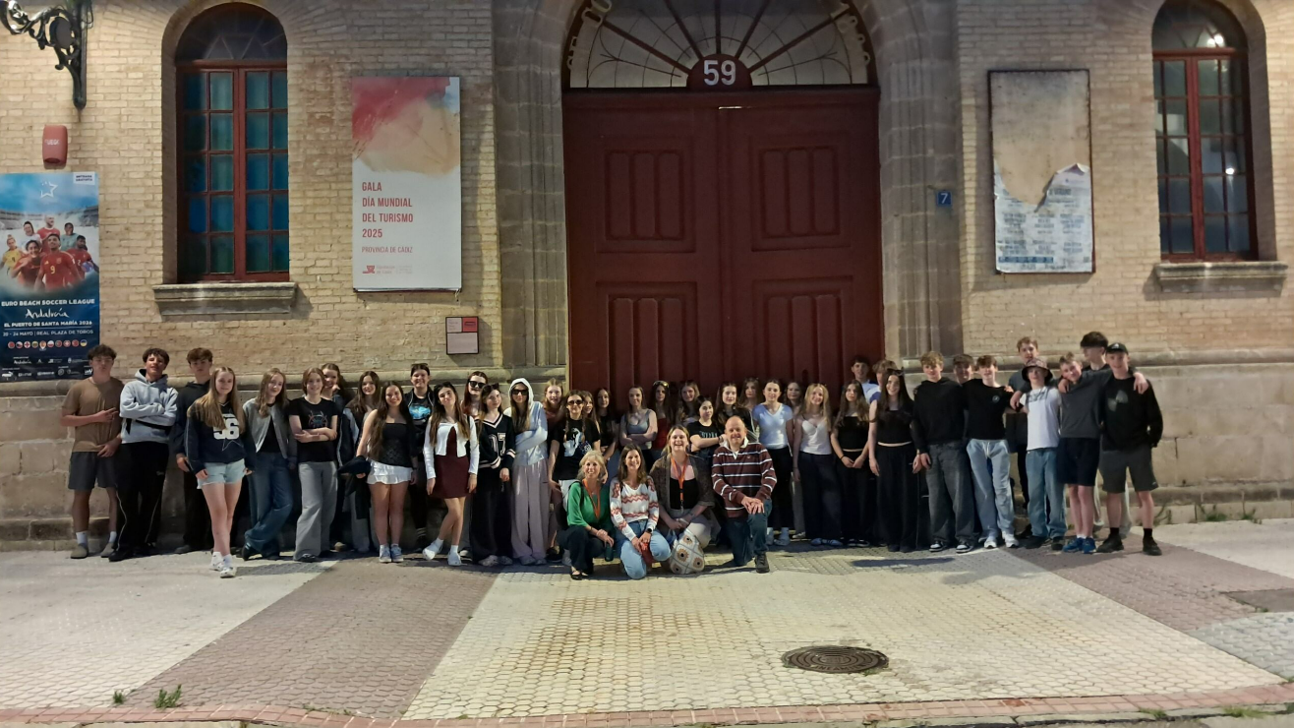
It was time for our last cena and closing ceremony. The students were praised for throwing themselves into the experience: asking intelligent questions, showing good humour, resilience and respect: KLB valores very much in action!
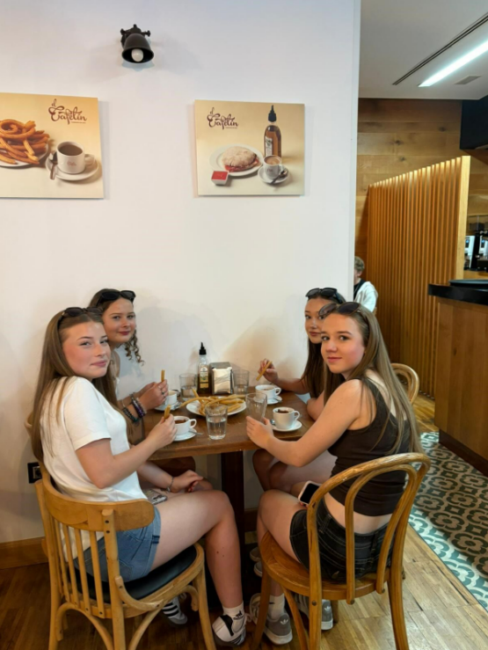
Our final morning was spent in the very typical Andalusian city of Jerez. What stood out here was the Alcázar, the purple flowered Jacaranda trees, the food market and stalls of caracoles. Some also caught a glimpse of a group in Flamenco dresses as they walked down the street. From el aeropuerto in Gibraltar we said adiós y hasta luego to España.
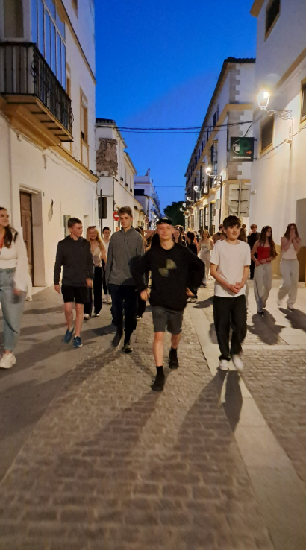
Muchas gracias to the students who made the most of this brief but packed viaje escolar. A special thank you to Sra Payne for having organised the trip and made it so inolvidable.

¡Hasta pronto!

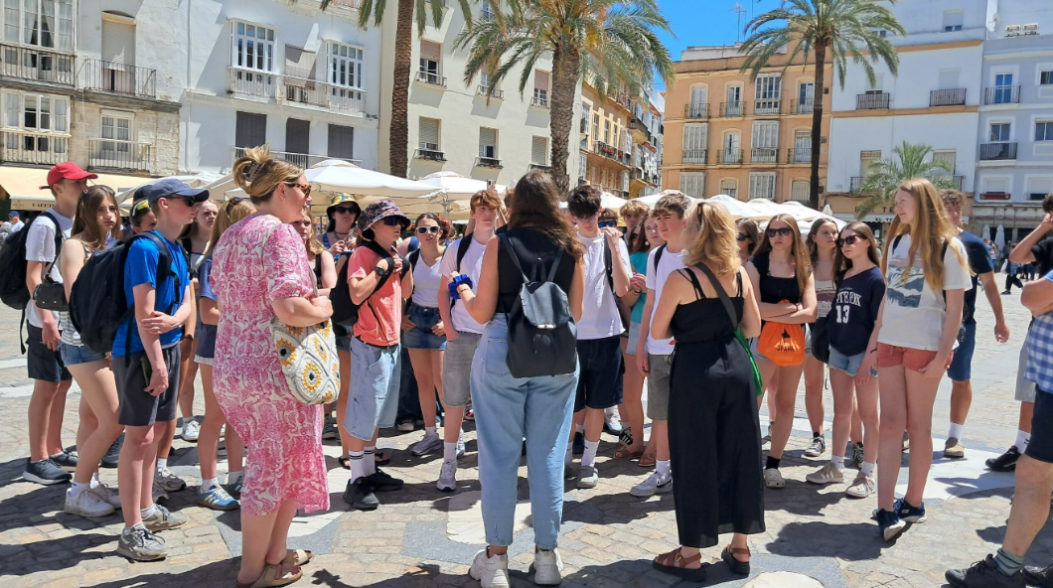

Year 12 Activities Week

The week following year 12 exams is an opportunity for students to develop their experience beyond timetabled lessons through a wide variety of activities – some departmental enhancements to the curriculum, others super- and extra-curricular opportunities that allow students to explore their interests and have new experiences.

Students learned to Teach English as a Foreign Language; completed a certificated First Aid course; learned skills for university entrance tests; undertook work experience in a wide variety of sectors from construction, hospitality and events management to teaching, veterinary medicine, and farming; created new art work for the sixth form spaces; supported in departments and lessons; completed online MOOCs (Massive Open Online Courses); pursued Extended Project Qualification research; attended lectures and events; completed their Gold Duke of Edinburgh Practice Expeditions; engaged in workshops to support research skills for coursework (Non Examined Assessment) and volunteered in the local community.

Each student pursued a personalised programme to help them make decisions about future plans and build strong applications to take them forward to their next steps. We were impressed by the diversity of students’ interests and are extremely proud of the way they conducted themselves within school and without.

Jane Campion, Head of Sixth Form
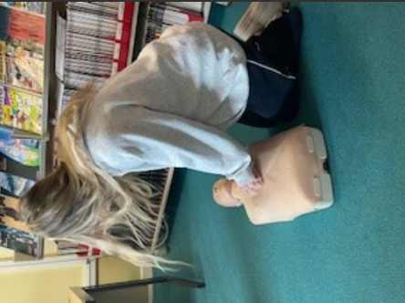
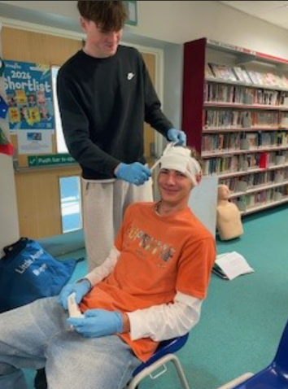
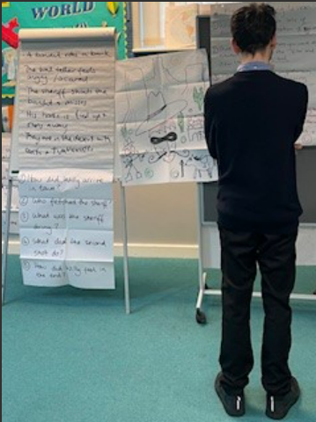
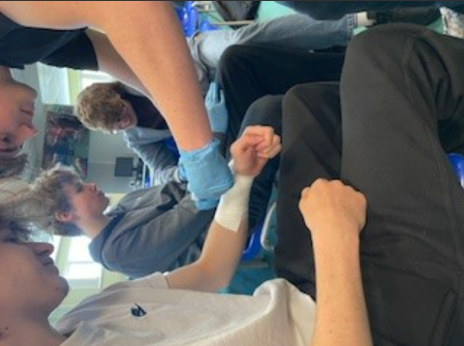
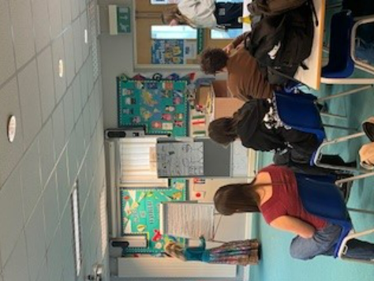
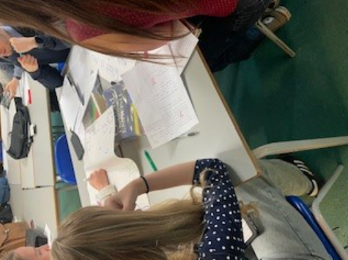


Lucas Payne attended a conference on family law as part of his work experience.
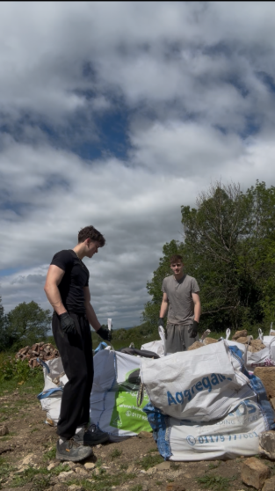
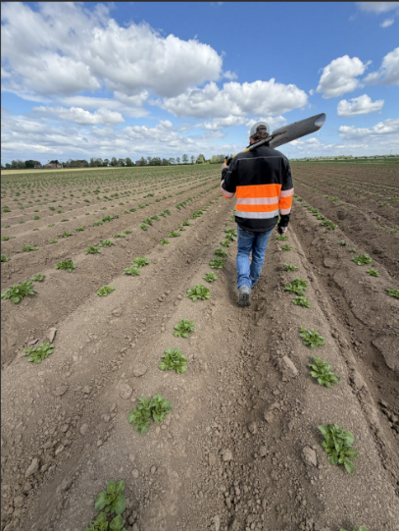
Matthias Forge checking potato crops with the farmer during his work experience (below right)

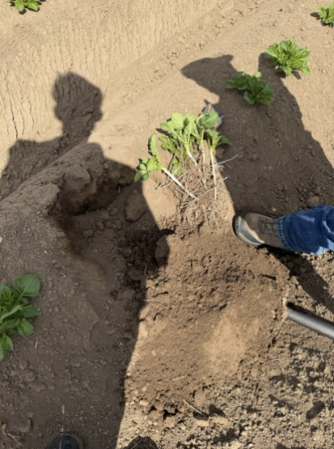
Louis Joseph and Joe Palmer Smith on work experience with a local contractor (left)

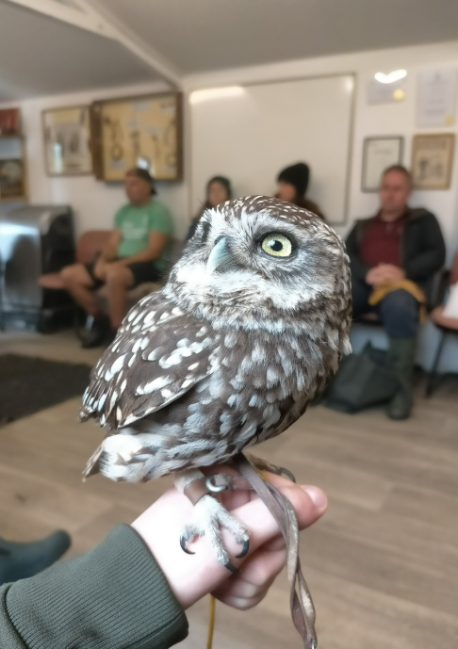
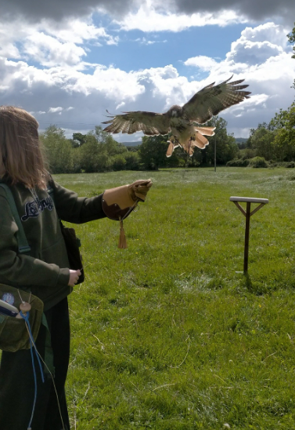
Evie Barnes completing her Raptor Award Course (left)

A Level Sociology Visit to Gloucester Crown Court
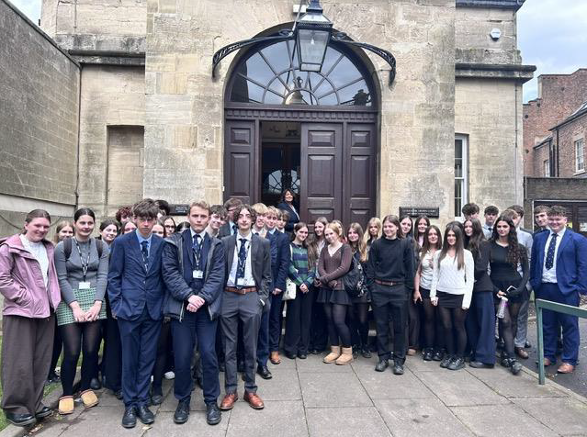

As part of our A level sociology course, we visited Gloucester Crown Court to learn about the judicial system and to reinforce what we have learnt during our sociology A level topic of crime and deviance. During our time at the court, we had the chance to ask questions that have arisen over the term and have them answered by a Court Judge and an ex-criminal. We were also able to observe two court cases, as well as a sentencing.

First, we had the exciting opportunity to receive a tour of the holding cells to see the conditions that defendants are kept in whilst waiting for their case in court. One of the security guards showed us the enclosed cells, which were small and consisted of just a wooden bench with no other amenities. He demonstrated the security system inside the court room which is used to protect the Judge and other attendants in the event of a violent outburst, from the accused, their family or another member of the public. He also showed us the protective suits and equipment used if officers need to enter a cell where a prisoner is trying to commit a harmful act against another person or themselves, or if they have managed to acquire a weapon.

We then sat in the main courtroom where the Judge spoke to us about how trials work and what his everyday working life is like. Following this, we were introduced to an ex-criminal who explained why he had gone to prison and who shared his experiences. He described prison as being extremely lonely and strongly encouraged us to avoid situations that could even accidentally lead to prison. He explained how prisoners can spend up to 23 hours a day locked in their cells, the long queues for telephones which can prevent contact with family for weeks, and the dangers within prison such as stabbings, boiling-water attacks, and the lack of luxuries.

Afterwards, we sat in the public gallery and watched parts of three separate cases. The first involved allegations of stalking in a workplace; however, the defendant was not present due to illness, meaning the case could not proceed and had to be rearranged. In addition, the defendant’s lawyer failed to provide the correct witness list, which caused frustration for the Judge as he explained that court time is extremely valuable and had effectively been wasted. The second case involved allegations of sexual assault, where a formal hearing date was arranged.

The trip was valuable as it allowed us to have an in-depth view of the court system up close and reinforce what we have learnt so far in the crime and deviance topic. It also helped reinforce different aspects of sociology such as unconscious bias and primary and secondary socialisation and how this helps define someone's character and morals. A huge thank you to both Mr Poole and Mrs Kelly-Davies for organising this trip.

Dorka Rostas, Year 12
Gold DofE Practice Expedition
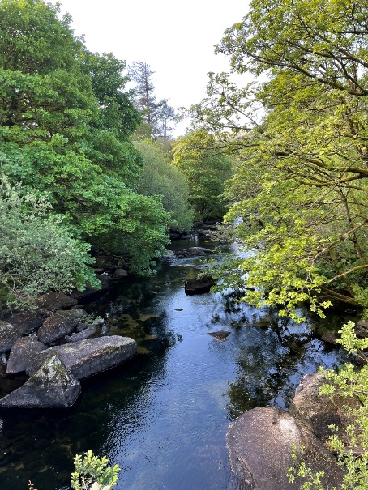
After waking up early, and a two-hour car ride to Devon, we arrived in Dartmoor. To our surprise, the weather was good, a pattern that continued throughout the expedition. On arrival we were greeted by the DofE leaders and met up with the rest of our team and began a bag check. The leaders went over all the equipment we would need in the coming days, including tents, maps a stove and first aid kits.
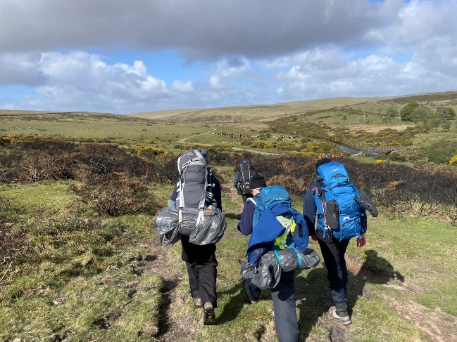
On the first day we were instructed by a leader, rather than going the wilds alone. This included learning how to take bearings from maps, as well as identifying waypoints and tic features, necessary skills when traversing low visibility environments like Dartmoor and the Black Mountains (the latter being the site of our final expedition). We travelled a total of around 9km, arriving at camp in the mid/late afternoon. The tent set up was easy, taking no longer than ten minutes. The evening was filled with fun games and activities involving all the teams. People had brought balls and cards, and a rounders kit was supplied by the leaders. Dinner dishes included boil-in-a-bag meals as well as other camping foods, a personal favourite being the wayfarer chicken tikka with rice. We were in our tents by 10pm, tired out by the day’s activity.

Waking up early on day 2, we had begun preparing breakfast when we were greeted with a small shower of rain: luckily this would not be the trend for the rest of the day. Today we set out alone having prepared our routes the night before. The day’s trek took us over the moors where, to our delight, we were greeted with some of the most extreme wind I have ever experienced. Despite this we toughed our way along the route, stopping for lunch and snack breaks at various points of cover. We travelled down a path called the Widowmaker (famous in Dartmoor as a mountain biking path) which luckily did not live up to its namesake as we traversed it on foot. We arrived at camp again in the early afternoon, travelling a grand total of around 20km. The evening was again filled with a variety of fun games and activities.
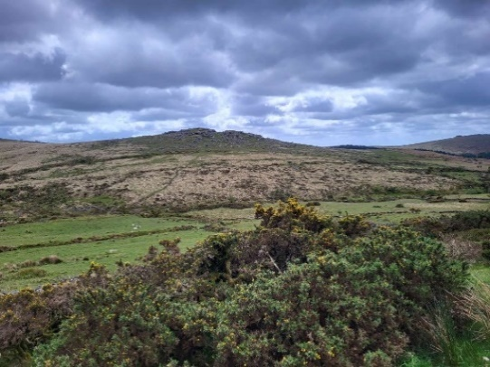
We had another early start on our final day. After breakfast, we cleaned and packed our equipment, before setting out on the final stretch of the expedition. This was probably the worst day weather wise, as we experienced various bouts of hail and rain on top of moors, but of course, we were all prepared! As we approached our destination, a small carpark in Princetown, the weather, rather poetically might I add, became the wettest we had seen all week. None the less, completing the practice expedition was a joy for all. The day 3 route covered a total of around 12km.

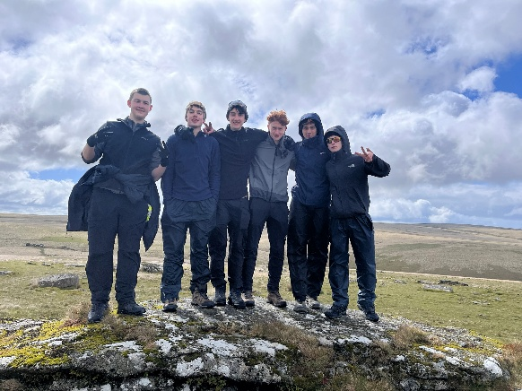
Overall, the Gold DofE practice expedition was an extremely positive experience. Sure, there were low points, including snoring from certain teammates during the night, but I think we are all better off because of it. I had the opportunity to become closer to friends, teammates and even classmates I would not regularly talk to, as well as experiencing the beautiful environment that is Dartmoor. I would recommend Gold DofE to any and every student who is interested in taking part in a fun challenge in which you gain core skills, teamwork, leadership, and resilience, as well as becoming closer to friends and classmates alike.

Thank you DofE and Ocean Rock!

James Guy, Year 12
Duke of Edinburgh Practice Expeditions

May saw DofE participants at all levels set off on their Practice expeditions.
The Silvers went first and sadly were not blessed with the best of spring weather. Heavy downpours on the first day meant a thorough drenching - a test for the waterproofs and dry liners! Well done to the students who persevered to the end despite the sogginess and extra blisters – your resilience and determination is truly impressive.

The Gold hikers also had a taste of how it feels to be exposed to the elements on Dartmoor but they and the canoeists on the Wye had successful expeditions and, as always, made a fantastic impression on the Ocean Rock team.

The Bronze groups had better conditions. As DofE novices, the goal at this level is always Teamwork; the students soon realise that navigating independently and self-sufficiently through the countryside while supporting members of their team is a genuine challenge. The reward is the real sense of pride and achievement the students gain from rising to this challenge.

I hope that participants at all levels are now looking forward to their Assessed expeditions in the summer term and achieving this section of their DofE award programme.

Thank you to the Ocean Rock team who supported and guided our students through their practice expeditions and summarised the experience as follows:

From hail on windswept Dartmoor for the Gold Foot, to water guns on the Wye for the paddlers; then amazing bronzes; to rain-soaked Quantock Silvers … well done to all the DofE’ers at KLB!!
As always, it has been a real privilege to share adventures with KLB in the great outdoors.
And the team at OceanRock remain super impressed by your manners, resilience, spirit and sense of fun.
Thanks to all the parents and carers for sending such well-prepared participants and for your kind words of encouragement at the meet points. A shout out to Miss Isaacs for getting us all there, and to Mr Thomas for taking the time share the Bronze expedition with us, thank you.
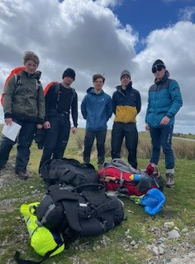
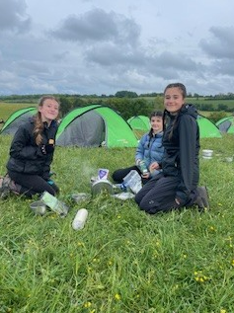
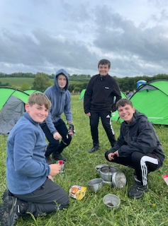

Helen Isaacs, DofE Coordinator

Library News

It’s Book Award Season!

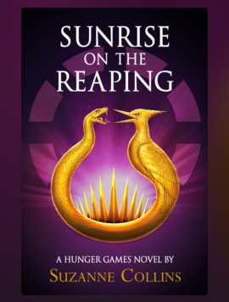
It is that time of year when book awards are announcing their shortlists and some have already awarded their prizes for 2026 – perfect timing for choosing a book to read over the half term break.

The British Book Awards or ‘Nibbies’ have awarded the Children’s Book prize to Sunrise on the Reaping by Suzanne Collins. This Hunger Games prequel is already a popular choice in the library – why not read it before the film version is released later on in the year to see which tells the story best? In our view, the book is always better!



The 2026 Waterstones Children’s Book Prize for Older Readers has been awarded to A Language of Dragons by S F Williamson.

This pacey fantasy novel is the first in a ‘Dark Academia’ series and is full of twists and turns with some romance thrown in – a worthy winner.

The winning titles of both competitions are available to borrow in the library.

Book shadowing continues….

The shadowing of both the Carnegies and Spark! Book Awards are continuing in school as students read through the shortlists before voting for their favourites. The judges for these awards will announce their winners in June – watch this space!

Literary Festivals
There are a few literary festivals happening in May which are always fantastic events, full of inspiring author talks, workshops and more. Click on the links for more details.

The Hay Festival – (21 to 31 May 2026) Located in Hay-on-Wye, this world-renowned festival features globally celebrated authors, thinkers, and performers in the heart of the Welsh book town.

Bath Literary Festival - (16 to 24 May 2026): This year’s programme includes some of the UK’s most celebrated authors, poets, historians and comedians.

KS3 Reading Project
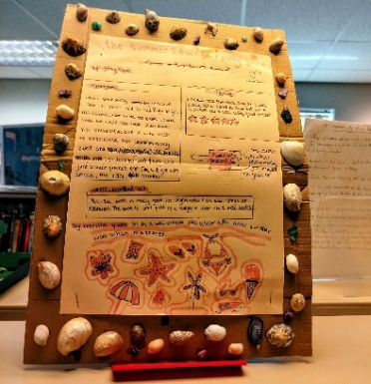
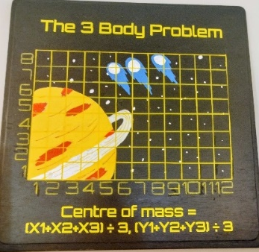
The library is proud to host a display of the wonderful responses to this year’s Reading Project. We are so impressed by the variety of books our students read, and the creativity and effort they have shown.

A board game has been created, 3D models made, collages and artwork crafted, as well as great book reviews and creative writing. Very well done to everyone involved!
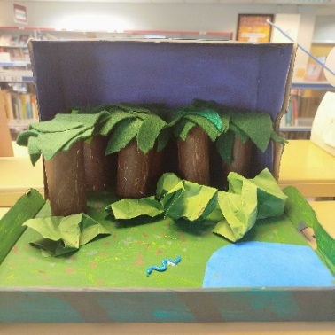
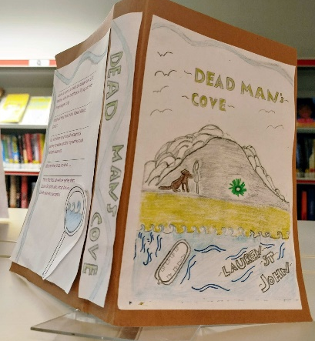
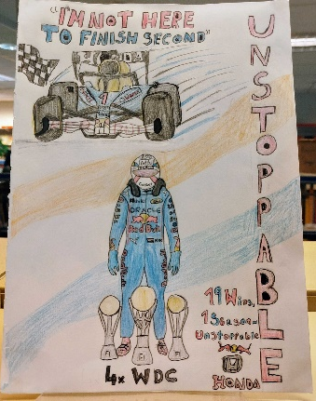
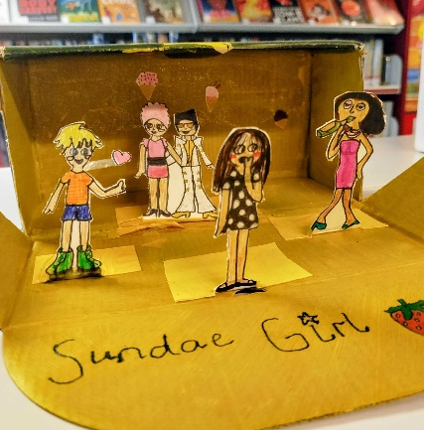

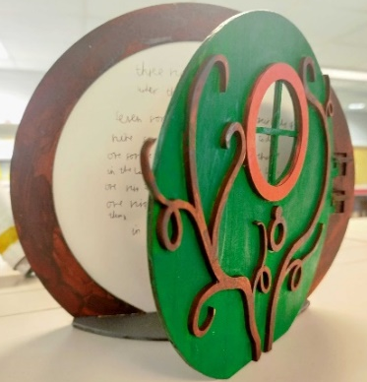
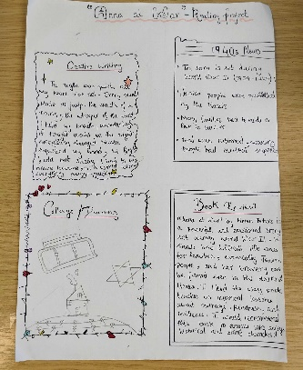

L Hill and N Dix, Librarians

Coding Challenge

The raspberry pi coding challenge results are in and many students came in the top 10% of all participants. The winners for each stage of the competition were:

Novice
Thomas Curtis
Ella Jeffreys Jones
Mathilda Morgan
Caelan Turner

Explorer
Arlo Watson

Navigators
Julian Kemp

Trailblazers
Oscar Richards Garcia

H Ferris, Computing Teacher
House Update

All Houses have now scaled the 1000 points mark, which is an amazing achievement.

House Football and Rugby Matches made a huge difference to the standings at the end of Term 5 with Berkeley tumbling from 1st to 3rd meaning our new leaders are Durand!
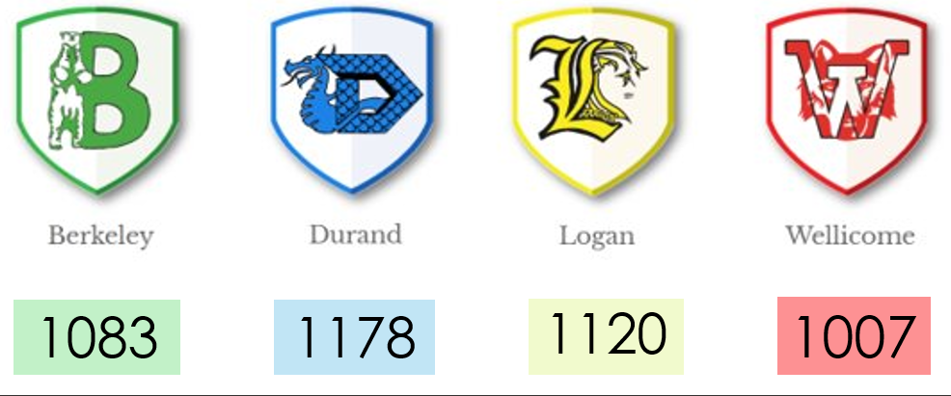

As ever, the fight is still on with plenty of points still up for grabs!

Fans of Dungeons and Dragons have until Friday 12 June to enter the latest competition (see below), and the House reading challenge continues until the start of July. House Bake-Off entries are starting to come in now with the year 10 and 12 deadlines straight after half-term. Who will make it through to the live final and which house will be crowned Bake-Off champions? Finally, a highlight of the House competition calendar is Sports Day. Will we see one house running away with the win, or another jumping and throwing for glory? - I can't wait to find out!

K Wyndow



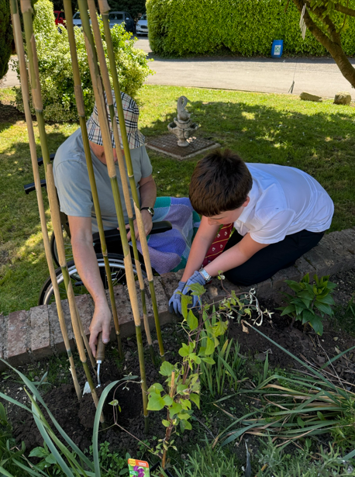
Horticulture News

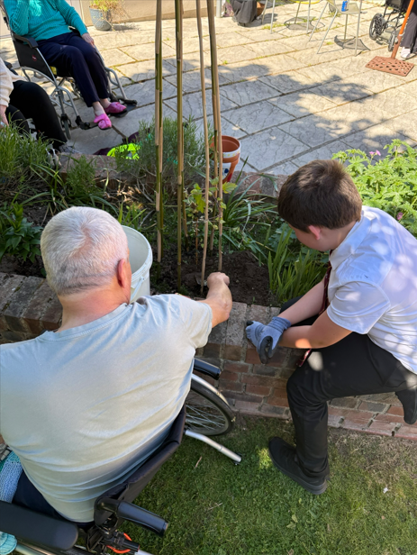
During their last few visits to the retirement home, horticulture students have been working with residents to enhance their garden space. They have been planting, sweet peas, silver dust, and some garden edibles such as kale and courgette.

They also worked with the residents making birdfeeders to hang in the trees, so when the residents are indoors in the conservatory, they can watch the birds.
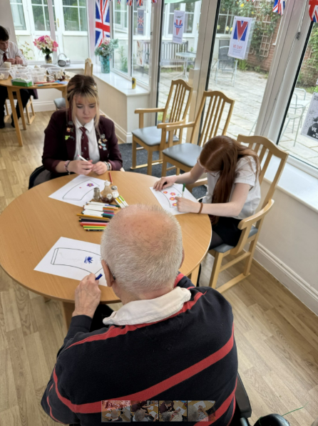
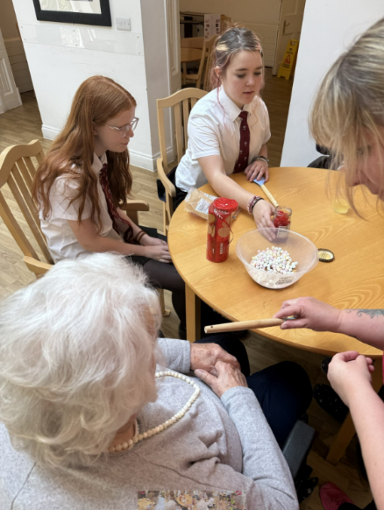
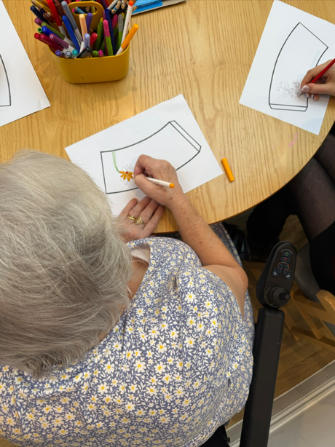
The residents and students were also keen to make some rocky road!

Emma Taylor-Roach, Horticulture Teacher

Keepers Volunteering

The Keepers Community Hub currently has an opportunity for a young volunteer to pot wash in The Keepers Kitchen on a Tuesday lunchtime during the school summer holidays. The young volunteer would be supervised at all times and all our volunteers and staff have an enhanced DBS check. The role would be fully supported, PPE is provided and full training given. The hours of volunteering would be from: 12-2.30pm every Tuesday lunchtime in the Wotton Hub on Symn Lane.

The opportunity would suit a student from aged 14/15 years upwards; The Keepers would welcome multiple enquiries as this role could be shared.

This would be an excellent opportunity for students to enter the world of volunteering particularly in their local community. Great for CV applications and/or DofE hours too...

Interested students should email thekeepersvc@gmail.comSummer Term Attendance

Attendance News


As we move into the final term of the academic year, we’d like to take a moment to celebrate the fantastic commitment many of our students are showing to their attendance. Well done!

The summer term is a busy and exciting time, but it’s also incredibly important. Students are continuing to learn, build confidence, and prepare for the next stage of their education, so every day really does count.

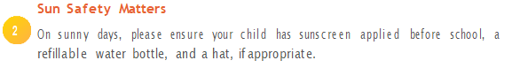
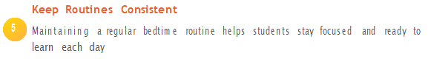
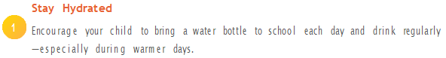
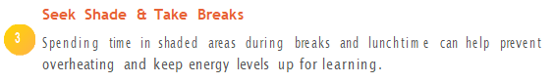
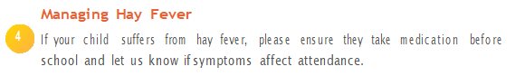
Top Tips for a Safe and Successful Summer
Why Attendance Still Matters Now
- Important learning and assessments continue right up to the end of term
- Students begin preparing for the next academic year
- Strong attendance habits now set students up for a positive start in September


KLB Friends News

We start with a request for your help with the following upcoming Events and Activities:

Charfield Village Fete Saturday 6 June

Bottle Tombola-- https://volunteersignup.org/ALF94

Bottle Tombola Donations Needed! We need more bottled items for our popular Bottle Tombola Stall — and we’d love your help! If you’re able to donate, please send items in with your student to KLB Reception by Wednesday 23 June.

Suggested donations include:

- Shower gel
- Non-alcoholic drinks
- Cordials
- Perfume
- Moisturiser

KLB Friends Carnival and Classic Car Show — Saturday 11 July 12-5pm

Calling all Parents – Get Involved in the KLB Friends Carnival!

The KLB Friends Carnival and Classic Car Show on Saturday 11 July is fast approaching, just six weeks away and we need your help to make it a huge success! Whether you can lend a hand for an hour, run a stall, serve refreshments, or help tidy up — your involvement truly matters.

Thanks to your support, KLB Friends has funded resources and equipment across the Languages, Art, PE, Music, SEND, Science, and Clubs departments — there isn’t a student at KLB who hasn’t benefited from our fundraising.

By volunteering, you’re not just helping on the day — you’re helping to create opportunities, experiences, and memories that last far beyond the carnival.

We’re looking for a team of volunteers to run the hugely successful BBQ: do you have a group of friends who like to sizzle a sausage or flip a smash burger? Then get in touch or come along to our meeting on Thursday 4 June at 6pm in the Swan Hotel Wotton.

We need Stallholders, Sponsors & Raffle Prizes
We are on the lookout for:
- Brilliant stallholders
- Exciting raffle prizes

If you or someone you know can support the event — whether you’re a local business, a crafty creator, or simply someone who loves backing the school — we’d be thrilled to hear from you.

Volunteers Needed: BBQ and Tea Room Team
We’re also building a friendly crew to run the BBQ and Tea Room on the day. If you enjoy being part of the action, love a busy atmosphere, or just fancy helping for a couple of hours, this is a fantastic way to get involved. No experience needed — just enthusiasm. If you can help in any way, big or small, please reach out. Your support genuinely makes this event possible.

Please watch out on social media for the volunteer sign-ups.

EasyFundraising App: https://www.easyfundraising.org.uk/causes/klbfriends

Get in Touch
We’re always excited to welcome new faces and fresh ideas. Every contribution helps make our fundraising events a success — with all monies raised going directly towards enriching students’ educational experience at KLB School.

Email: klbfriends@klbschool.org.uk or our new email address Admin@klbfriends.co.uk

The KLB Friends Committee
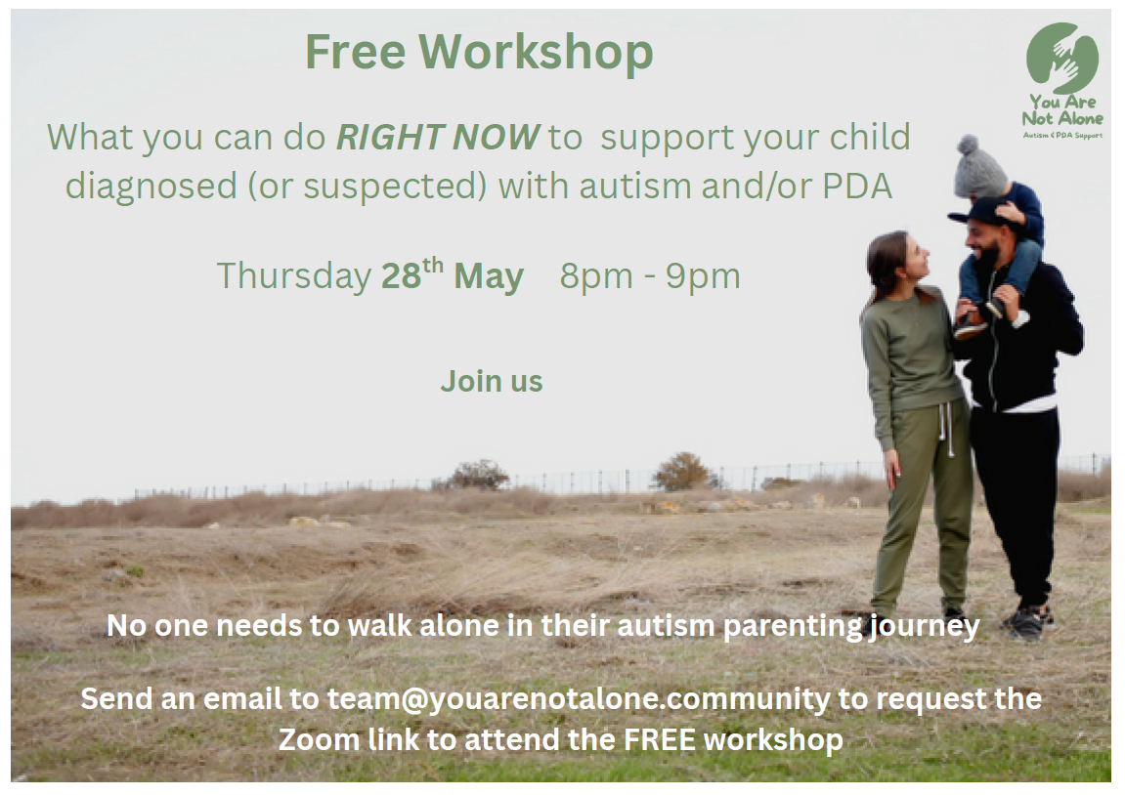

The Berkeley Parochial Trust

Is life a struggle at the moment? We may be able to give a little help.

The Berkeley Parochial Trust is a small local charity that is able to offer modest financial one-off help for a particular purpose, to local people who are on a limited income and struggling to manage.

Anyone who lives within one of the five Berkeley Parishes (Berkeley, Alkington, Ham & Stone, Hamfallow, and Hinton) is eligible to apply.

We are sorry that we are unable to offer help with debt or school transport fees, but perhaps there are other necessary things that you are desperate for and just cannot find the money? Many essential things can seem impossible to obtain, when times are hard.

Contact us to explain your situation, and let us see if the Trust can help?

The Trustees will consider each application on an individual basis. Their decision is final. Any help given does not have to be repaid. We will need to know a name, address and some details of your family and financial situation.This will be kept confidential within the Trust.

To apply please contact our Clerk, Heather (email if possible) bptgl13@gmail.com or if you can’t access email, phone 07419 310395 and leave a message and phone number.

